**Project Design Phase-II**

**Data Flow Diagram & User Stories**

| Date | 06-11-2023 |
| --- | --- |
| Team ID | 591944 |
| Project Name | Time Series Analysis For Bitcoin Price Prediction Using Prophet |
| Maximum Marks | 4 Marks |

**Data Flow Diagrams:**

A Data Flow Diagram (DFD) is a traditional visual representation of the information flows within a system. A neat and clear DFD can depict the right amount of the system requirement graphically. It shows how data enters and leaves the system, what changes the information, and where data is stored.

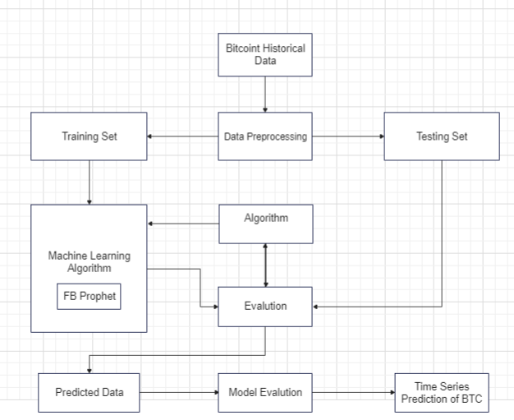

**User Stories**

| **User Type** | **Functional**  **Requirement (Epic)** | **User Story**  **Number** | **User Story / Task** | **Acceptance criteria** | **Priority** | **Release** |
| --- | --- | --- | --- | --- | --- | --- |
| Cryptocurrency Enthusiast | Accurate Predictions | us1 | As a cryptocurrency enthusiast, I want access to accurate Bitcoin price predictions. | The system provides daily, weekly, and yearly Bitcoin price forecasts. | High | Initial Release |
| Novice Investor | Real-Time Predictions | us2 | As a novice investor, I want real-time Bitcoin price forecasts that are easy to understand. | The system provides up-to-the-minute Bitcoin price predictions. | High | Initial Release |
| Financial Analyst | Research and Analysis Support | us3 | As a financial analyst, I need reliable Bitcoin price predictions to support my research and analysis. | The system offers historical and real-time Bitcoin price data for analysis. | Medium | Initial Release |
| Data Scientist | Model Experimentation | us4 | As a data scientist, I seek a flexible platform to experiment with Bitcoin price prediction models. | Model performance metrics and historical data are available for analysis. | Medium | Initial Release |
| Fintech Entrepreneur | Integration with Trading Platform | us5 | As a fintech entrepreneur, I aim to integrate Bitcoin price predictions into my trading platform. | Predictions can be seamlessly integrated into the entrepreneur's trading software | High | Later Release |
| Risk Manager | Risk Assessment | us6 | As a risk manager, I rely on accurate predictions to assess and mitigate financial losses. | Users can set risk thresholds and receive alerts. | High | Initial Release |
| Project Supporter | Project Dedication | us7 | As a project supporter, I appreciate the dedication of the project lead to ensure its success. | The project receives positive feedback and recognition from users and the community. | Low | Ongoing Support |